**WEST AFRICAN POSTGRADUATE COLLEGE OF NATURAL AND INTEGRATIVE MEDICINE**

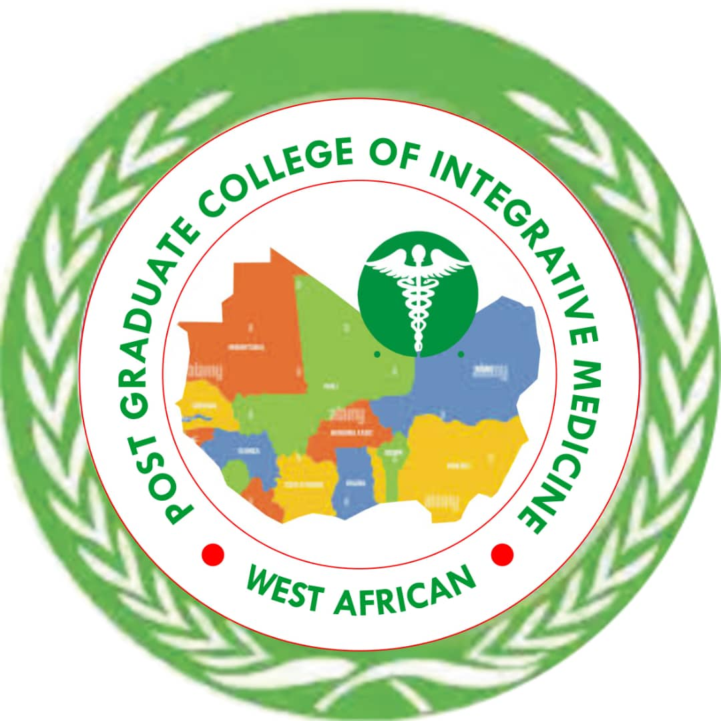

**PROFESSIONAL DOCTOR OF CHIROPRACTIC MEDICINE PROGRAMME DEVELOPED IN COLLABORATION WITH THE ASSOCIATION OF CHIROPRACTIC PRACTIONERS, NIGERIA**

**ADOPTED BY THE ASSOCIATION OF PROVOSTS AND HEADS OF ALTERNATIVE MEDICINE COLLEGES AND INSTITUTIONS, NIGERIA**

**AND**

**ASSOCIATION OF PROFESSORS AND CONSULTANTS OF TRADITIONAL COMPLEMENTARY AND INTEGRATIVE MEDICINE.**

**Professional Doctor of Chiropractic medicine programme (In Collaboration with the Chiropractic Practitioners, Nigeria)**

**Overview**

The goal of the Professional Doctor of Chiropractic medicine and Public Health programme is to train personnel and obtain manpower that are knowledgeable in basic, medical, pharmaceutical, botanical and social sciences that will be competent to practice as health professionals, using available facilities to liver acceptable quality healthcare services.

The curriculum will cover Chiropractic philosophy and principle, Nature cure, Asian medicine, African Medicine, Clinical Nutrition, Counseling, Physical therapy, Minor surgery, etc.

**Objective**

The objective of Chiropractic medicine and Public are to:

1 Provide world-wide and world renowned alternative system of healthcare;

2 Increase the number of collaborative healthcare workers, thereby, reducing morbidity and mortality.

3 Provide the knowledge and skills needed for Chiropractic medicine and Public practices;

4 Promote research and development in Chiropractic medicine and Public; and

5 Facilitate collaboration between orthodox and traditional medicine practitioners.

**Employability skills**

On completion of the programme, it is expected that graduates will be registered with the relevant regulatory body and eligible to practice as healthcare professionals, after internship in government approved institutions.

Graduates may find employment:

In private hospitals and public hospital establishments or institutions (including teaching, research, manufacturing, quality control or marketing of comparative and alternative medicine products or work in related fields, such as pharmaceuticals or foods) as a civil. Public servant in the public health service sector (such as in NAFDAC, Research Institutes, Universities or Ministries of Health); Set up a personal private and public herbal production, wholesale, retail or clinical practice outfit as a community practitioner, providing basic primary healthcare; Employment either in the Regulatory and services Agencies under the Ministries and Agencies.

**Admission and Graduation requirements**

Admission requirements candidate may be admitted by Six-year programme or by direct entry, the minimum academic requirements is credit level passes in five subjects at senior secondary certificate including; English language, Mathematics, Physics, Chemistry and Biology at not more than two (2) sittings.

**Direct Entry**

Candidate seeking admission through this mode should in addition to a minimum of five SSC credit passes possess:

1 Passes in Physic, Chemistry and Biology at the Higher School Certificates or Advanced Level of General Certificate Examination or its equivalent or

2 An acceptable First Degree of minimum of second class lower in relevant Biological or Physical Science disciplines.

**Course Structure**

**100level**

|  |  |  |  |  |  |
| --- | --- | --- | --- | --- | --- |
| Course Code | Course title | Unit (s) | Status | LH | PH |
| GST 111 | Communication in English | 2 | C | 15 | 45 |
| GST 112 | Nigerian Peoples and Culture | 2 | C | 30 | - |
| BIO 101 | General Biology I | 2 | C | 30 | - |
| BIO 102 | General Biology II | 2 | C | 30 | - |
| CHM 101 | General Chemistry I | 2 | C | 30 | - |
| CHM 102 | General Chemistry II | 2 | C | 30 | - |
| CHM 107 | Practical Chemistry I | 1 | C | - | 45 |
| CHM 108 | Practical Chemistry II | 1 | C | - | 45 |
| MTH 101 | Elementary Mathematics I | 2 | C | 30 | - |
| PHY 101 | General Physics I | 2 | C | 30 | - |
| PHY 102 | General Physics II | 2 | C | 30 | - |
| PHY 107 | General Experimental Physics I | 1 | C | - | 45 |
| PHY 108 | General Experimental Physics II | 1 | C | - | 45 |
|  | Total | 22 |  |  |  |

**200Level**

|  |  |  |  |  |  |
| --- | --- | --- | --- | --- | --- |
| Course Code | Course title | Unit(s) | Status | LH | PH |
| ENT 211 | Entrepreneurship and Innovation | 2 | C | 30 | - |
| GST 212 | Philosophy, Logic and Human Existence | 2 | C | 30 | - |
| ANA 201 | Anatomy of Upper and Lower Limbs | 2 | C | 30 | - |
| BCH 201 | General Biochemistry I | 2 | C | 30 | 45 |
| BCH 216 | Biochemistry practical | 2 | C | - | 90 |
| PIO 201 | Introductory Physiology & Blood | 2 | C | 30 | - |
| PHA 201 | General Pharmacology | 2 | C | 30 | - |
| MCB 201 | Introduction to Microbiology and Infection Control | 2 | C | 30 | - |
| ANA 202 | History of Basic Tissues | 2 | C | 15 | 45 |
| ANA 204 | Anatomy of Thorax Abdomen, Pelvis & Perineum | 2 | C | 15 | 45 |
| PIO 203 | Physiology of Excitable Tissues | 2 | C | 30 | - |
|  | Total | 22 |  |  |  |
| **FIRST PROFESSIONAL EXAMINATION** | | | | | |

**300 Level**

|  |  |  |  |  |  |
| --- | --- | --- | --- | --- | --- |
| Courses code | Course title | Unit (s) | Status | LH | PH |
| ENT 312 | Community Health | 2 | C | 15 | 45 |
| GST 312 | Principles of Minor Surgery & Medical Therapeutics | 2 | C | 30 | - |
| APT 301 | Principles of Public Health | 2 | C | 30 | - |
| CPY 311 | Introductory Immunology | 2 | C | 30 | - |
| CPY 302 | Introductory Chemical Pathology | 2 | C | 30 | - |
| CAM 301 | Introduction to Herbal Medicine | 2 | C | 30 | - |
| NAT 305 | Chiropractic philosophy and principle | 2 | C | 30 | - |
| HOM 310 | Nature cure | 2 | C | 30 | - |
| NAT 317 | Asian medicine | 2 | C | 30 | - |
| NAT 318 | African Medicine, | 2 | C | 30 | - |
| NAT 319 | Clinical Nutrition | 2 | C | 30 | - |
| NAT 301 | Counseling | 2 | C | 30 | - |
| NAT 304 | Physical therapy | 2 | C | 30 | - |
|  | Total | 26 |  |  |  |

400 Level

|  |  |  |  |  |  |
| --- | --- | --- | --- | --- | --- |
| Courses code | Course title | Unit (s) | Status | LH | PH |
| CHR 305 | Foundation of philosophy and theory | 3 | C | 30 | - |
| CHR 310 | Motion Palpation | 3 | C | 30 | - |
| CHR 317 | Biomechanics | 3 | C | 30 | - |
| CHR 318 | Comparative Techniques and listing systems | 2 | C | 30 | - |
| CHR 319 | General Technique I - Diversified | 2 | C | 30 | - |
| CHR 301 | General Technique II – Upper Cervical | 2 | C | 30 | - |
| CHR 302 | Advanced Manual Therapy Technique | 2 | C | 30 | - |
| CHR 303 | Manipulation Rehabilitation Review | 2 | C | 30 | - |
| CHR 304 | Functional Rehabilitation – Exercise Physiology | 2 | C | 30 | - |
| CHR 306 | Functional Rehabilitation – Advanced Manual Medicine | 2 | C | 30 | - |
| CHR 307 | Physiological Therapeutics - Modalities | 2 | C | 30 | - |
| CHR 308 | Chiropractic Management of Special population Geriatric, Pediatric, Adolescent, Pre- and Pre-natal | 2 | C | 30 | - |
| **SECOND PROFESSIONAL EXAMINATION** | | | | | |

500 Level

|  |  |  |  |  |  |
| --- | --- | --- | --- | --- | --- |
| Courses code | Course title | Unit (s) | Status | LH | PH |
| CHR 305 | Foundation of philosophy and theory | 3 | C | 30 | - |
| CHR 310 | Motion Palpation | 3 | C | 30 | - |
| CHR 317 | Biomechanics | 3 | C | 30 | - |
| CHR 318 | Comparative Techniques and listing systems | 2 | C | 30 | - |
| CHR 319 | General Technique I - Diversified | 2 | C | 30 | - |
| CHR 301 | General Technique II – Upper Cervical | 2 | C | 30 | - |
| CHR 302 | Advanced Manual Therapy Technique | 2 | C | 30 | - |
| CHR 303 | Manipulation Rehabilitation Review | 2 | C | 30 | - |
| CHR 304 | Functional Rehabilitation – Exercise Physiology | 2 | C | 30 | - |
| CHR 306 | Functional Rehabilitation – Advanced Manual Medicine | 2 | C | 30 | - |
| CHR 307 | Physiological Therapeutics - Modalities | 2 | C | 30 | - |
| CHR 308 | Chiropractic Management of Special population Geriatric, Pediatric, Adolescent, Pre- and Pre-natal | 2 | C | 30 | - |

600 Level

|  |  |  |  |  |  |
| --- | --- | --- | --- | --- | --- |
| Courses code | Course title | Unit (s) | Status | LH | PH |
| CAM 402 | Clinical Training | 4 | C | - | 160 |
| CAM 413 | Research Methodology | 3 | C | 45 | - |
| CAM 414 | Policy, Laws and Ethics in Complementary and Alternative Medicine Practice | 3 | C | 45 | - |
| CAM 404 | Public Health in Complementary and Alternative Medicine | 2 | C | 30 | - |
| HOM 404 | Homeopathic in Clinical Practice | 6 | C | - | 270 |
| CAM 400 | Project | 6 | C | - | 270 |
|  | Total |  |  |  |  |
| **FINAL PROFESSIONAL EXAMINATION** | | | | | |